Conference Program

The conference venue:
YUANZHENG QIZHEN Hotel
No 866 Yuhangtang Road, Hangzhou
会议酒店：圆正启真酒店
杭州市西湖区余杭塘路866号（浙江大学紫金港校区内）
Hotel website: www.yz-hotels.cn
园正启真酒店房间十分紧张，请参会作者提前自行预定酒店房间。
园正启真酒店订房电话：0571-88202888(预定时报浙江大学计算机学院会议为协议价)
紫金港校区附近还有其他酒店，如紫金港国际饭店、紫金港大酒店、香树e家商务酒店。
紫金港国际饭店订房电话：0571-89710000
紫金港大酒店订房电话： 0571-89977006
香树e家商务酒店订房电话：0571-87361535
August 25(Friday), 2017 (at YUANZHENG QIZHEN Hotel)
15:00 – 20:00, Registration

August 26 (Saturday), 2017 (at YUANZHENG QIZHEN Hotel)
8:00 — Registration
8:20 — 8:30 Opening Session (Qiushi Hall on the 3th floor)三楼求是厅
8:30 — 9:00 Keynote talk
Prof. Zengchang Qin (Beihang University)

9:00 — 10:20 Session 1 (15 mins per presentation)- (Qiushi Hall on the 3th floor)三楼求是厅
(Moderator: Zejian Lee)

30 An Efficient Text Entry Model for Scanning Ambiguous Keyboard "FARZANA JABEEN, LINMI TAO"

61 On the conduction of nerve signals along coupled axons using a pairwise statistical description "Qichun Zhang, Francisco Sepulveda"

152 RF Receiver Front-End and Frequency Synthesizer Integrated for Intelligent Human-Machine Systems and Wireless Cybernetics Wen-Cheng Lai

209 Development of Emotion Teaching Interfaces using Emoticons and Emojis Yasuhiro Matsuda

240 A Natural User Interface for Realistic Tactile Perception of Object Surface Texture "Zih-Hao Lin, Shana Smith"

10: 10— 10:20 Coffee break
10:20 — 12:00 Session 2 (15 mins per presentation)- (Qiushi Hall on the 3th floor)三楼求是厅
(Moderator: Zejian Lee )

51 Analysis of Product Evaluations: An Adaptive Approach Based on Extended Sentiment Dictionaries "Chunli Zhao, Chunjing Hu, Tao Peng"

57 Vehicle Target Recognition System Based on Fuzzy Control for Millimeter Wave Radar "ZengMu Cheng,XinLei Liu,TianYu Qiu"

60 A Mixed-Signal Spiking Neuromorphic Architecture for Scalable Neural Network "Chong Luo, Zhangzhong Ying, Xiaolei Zhu, Longlong Chen"

251 "Formal Modeling, Analysis and Verification of Black White Bakery Algorithm" "M. Saqib Nawaz, M. Ikram Ullah Lali, Sun Meng"

27 Research on Position Sensorless Control System of High-Speed Brushless DC Motor "RongChun Guo,ZengMu Cheng,JinDong Li"

62 Modeling of Boiler Steam Flow Based on Adaptive Least Squares Support Vector Machine "Yu Wang,Zhenhao Tang,Bo Zhao"

12:00 — 13: 20 Lunch （on the 1st floor）
13:20 — 15:20 Session 3 (15 mins per presentation)- (Shunshui Hall on the 4th floor)四楼舜水厅
(Moderator: Yunsong Xiao)

95 Research on Entity Recognition in Traditional Chinese Medicine Diet Yingying Zhao

100 Research on Fractional Delay Filter and Mismatch Feature based on Least Mean Square Rule for CI Device "Yousheng Chen, Weifang Chen"

103 Design of urban greening intelligent monitoring system based on Internet of Things technology "Di Qi, Guoping Lu, Xinglei Dai"

109 Hybrid Control Scheme Consisting of Adaptive and Optimal Controllers for Flexible-base Flexible-joint Space Manipulator with Uncertain Parameters "Zhiyong Chen, Tingting Zhang, Zhenhan Li"

116 Infrared signal based elderly fall detection for in-home monitoring "Qiuju Guan, Caiyong Li, Xuemei Guo, Baihua Shen"

196 RBM-based Back Propagation Neural Network with BSASA Optimization for Time Series Forecasting Li Huiyuan

137 A FAST RBFN BASED MPPT METHOD FOR APPLICATION OF TRIPLE-JUNCTION SOLAR CELL "Dinghao Li, Junquan Cao, Xiongxiong He"

147 A Four-Phase Dual-Rail Protocol based Asynchronous Arbiter for Neuromorphic Networks "Longlong Chen, Zhaozhong Ying, Chong Luo, Xiaolei Zhu"

15: 20— 15:30 Coffee break
15:30 — 17:30 Session 4 (15 mins per presentation)- (Shunshui Hall on the 4th floor)四楼舜水厅
(Moderator: Yunsong Xiao)

198 Auxiliary Diagnosis of Breast Tumor based on PNN Classifier Optimized by PCA and PSO Algorithm "Jiawei Zhou, Tong Zhong, Xiongxiong He"

228 A system identification method to Hammerstein model based on Modified Shuffled Frog Leaping Algorithm "Jiangtao Zhai,Chengming Zhu,Chi He,Zhijun Yao,Yuewei Dai"

235 Three-Dimensional Human Modeling and Dynamics Simulation Based on ADAMS "Zhiwei Xu,Zirong Luo,Lei Ren,Kunyang Wang,Dan Hu"

236 Error Detection of Packing Box Based on Registration between Incomplete Point Cloud and CAD Model "Jiexin Zhou, Xiaohu Zhang, Nianhao Xie, Liang Xie, Yunna Bao"

244 Robust Time Delay Estimation Based Intelligent PID Control of a 6DOF upper-limb Exoskeleton Robot "Fei Fei, Haoping Wang, , Yang Tian"

245 sEMG-based Estimation of Knee Joint Angles and Motion Intention Recognition "Guoyuan Tang, Haoping Wang, , Yang Tian"

262 Research and Implementation of a Data Backup and Recovery System for Important Business Areas "Jianping Zhang, Hongmin Li"

17:30 — Banquet and Closing (on the 2nd floor)

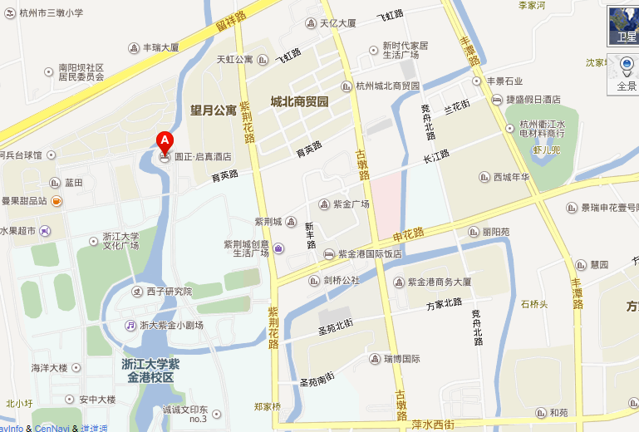
Baidu map of conference venue –YUANZHENG QIZHEN Hotel (圆正启真酒店)

